PRESIDENT’S OFFICE
REGIONAL ADMINISTRATION AND LOCAL GOVERNMENT
NAMANGA SECONDARY SCHOOOL
FORM FOUR SERIES TWO EXAMINATION
INFORMATION AND COMPUTER STUDIES

Time 2 Hours February, 2025

- This paper consists of sections A, B and C with a total of ten (10) questions.
- Answer all questions.
- Section A and C carry fifteen (15) marks each and section B carry seventy (70) marks.
- All answers must be written in blue or black ink.
- Cellular phones, calculators and any unauthorized materials are not allowed in the examination room.
- Write your Examination Number at the top right corner of every page.

SECTION A(15 Marks)
Answer All questions in this section
- For each of the items(i)-(x) ,choose the correct answer from the given alternatives and write in the box provided
  - The following are the vital roles of information in any community EXCEPT:
    - Helping to make better decisions
    - Giving records of future events
    - Producing knowledge and helping us to identify missing knowledge about a subject
    - Helping to identify opportunities for work ,business and innovation.

  - Why is it advised to set a strong password in the computer?
    - To restrict unauthorized user
    - To minimize computer virus
    - To prevent the computer from damage
    - To reduce unauthorized program

(iii).Which combination of keys is used to select the text in a document? A.Ctrl+P B:Ctrl+C
C.Ctrl+A D.Ctrl+P

(iv).How would you classify a touch screen among the computer hardware parts?
A.An input device C.Both processing and output device
B.An output device D.Both input and output device

(v).Data in the computer system is measured using different units, but the commonly used data measurement unit is:-
A. Gigabyte B.A byte
C.Megabyte C.Kilobyte

(vi).The main function of the router in the computer network is:-
A. To provide access to the internet
B. To provide interconnection with different networks
C. To converts signal from digital to analog form
D. Divide a busy network into segments

(vii).Computer software which perform fundamental operations like booting, retrieving and loading application is called:-
A. Drivers
B. Utility software
C. Database
D. Operating system

(viii). Kiswahili teacher wants to find the highest score of the of 30 students in spreadsheet, which of the following formula will be used to by the teacher?
A. =SUM(B1:B30)
B. =MAX(B1:B30)
C. =RANGE(B1:B30)
D. =COUNT(B1:B30)

- Examples of secondary storage memory devices are….
  - Floppy disk and ROM
  - Hard disk and RAM
  - ROM and RAM
  - Floppy disk and Hard Disk
- What is the most suitable input device for highlighting or selecting an object on the screen?
  - Joy stick
  - Mouse
  - Keyboard
  - Touch screen

- Match the functions of the features of the features of word processors in LIST A with their corresponding features names in LIST B by writing the letter of the correct answer below the item number is the box provided.
LIST A | LIST B
- Shows how the document will look like when printed  - Format your screen to make the reading of your document more comfortable  - Enables you to view your document ,as it would | - Read Mode  - Web Layout  - The Print Layout View  - Home Tab  - Insert Tab

appear in a browser .  - The tab contains a ribbon with various groups of commands such as Clipboards, Font, Paragraph,  Style and Editing  - Displays the program name and name of the current document you are working on | F. Title Bar  G. Menu Bar  H. Document Window

SECTION B(70 Marks)
Answer all questions in this section
- The following figure shows a physical arrangement of computers in a certain office. Study it carefully and answer the questions that follow:
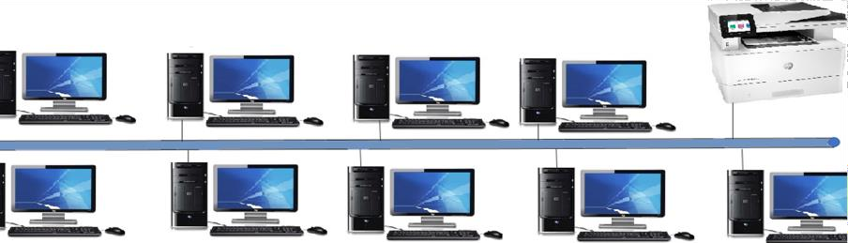
A
B

Figure 1
- What is the name of the physical topology presented in the figure provided?
- What are the names of the components labeled with later A and B?
(i). Letter A……………………….………………………………………. (ii).Letter B…………………………………………………………….
- What are the three advantages of the type of network used in the Figure1 (i4.(a) Give two advantages of choosing a laptop computer instead of desktop computers

(b)A desktop computer has five cords for it to function properly, name the cords with respect to the components they are connecting.
- Shadya is a Form One student who wants to practice on how to use Microsoft word program. Assist her to identify the steps of inserting the following:
  - A picture sored in My Documents

  - Tables with 3 rows and 5 columns

6.(a)The government has announced the issue of power shortage in the main line supplying power to Hai district. This led to the power fluctuation in the computer lab. Outline the two effects of power fluctuation in the computer lab
- What are the two devices should be used in solving the problem of power fluctuation in the computer lab?
- It is advisable to protect the computer from malicious program. What are the four things to be done regularly to protect the computer from malicious programs:

7.(a)Basic Mathematics teacher is using a computer to input,store,analyse results so as to know the progress of his students in the subject. Below is the snapshot of one of the works he is doing in the

Computer 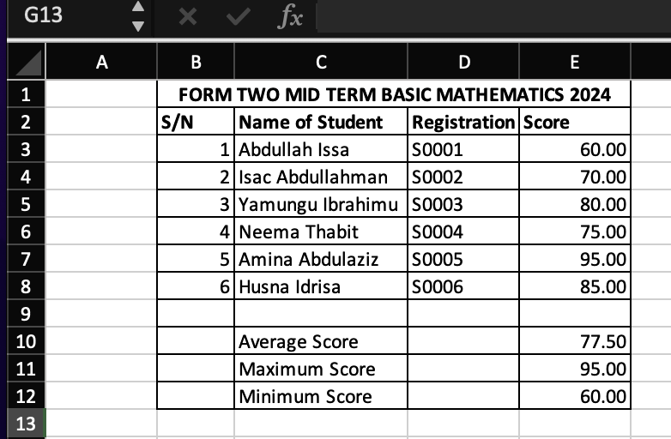
(a) What is the name of the software used to enter data:
(b)What are the two data types used in the worksheet?
(c) Write the formula for getting
- Average score
- Maximum score
- Minimum
What is the active cell in the Figure 2 above

8.(a) Due to the advanced in technology,mobile phones are widely used in communication and other tasks in the community.Give three reasons why mobile phones are regarded as computers.

(b)Give two reasons why the computer is regarded as electronic device

- In 2009 the world faced the tragic of COVID19 which started in China, one on the method to combat the disease was mass campaigns through different media. To reach the population the government of Tanzania decided to use modern communication media to provide news to the public.
  - Which communication media were used by the government? Give four

  - Why the government of Tanzania opted to use modern communication media to address the COVID19 pandemic to reach the public? Give three reasons

SECTION C(15 Marks)
Answer question ten(10)
- Explain three advantages and three disadvantages of computers in daily life.

